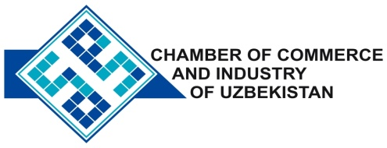

**Commercial offer of Uzbek Products to Foreign Buyer**

Dear Sirs, PSM-019

We offer quotation of Uzbek Company DP «MEHNAT HALOL»

**Information about the company:**

Subsidiary «MEHNAT HALOL» was founded in 2000. The main activity of the company is the production of various building materials.

**List of products:**

Steel tubes;

Wavy metal corrugated sheet;

Tin tin lids;

Steel wire;

Electrolyte steel;

Construction nail;

Metal and accessories thereto;

Profile steel curved trapezoidal corrugations (corrugated board).

**Benefits:**

All materials are produced in accordance with GOST and are of high quality.

**Terms of delivery:** FCA Tashkent

If you are interested, we are happy to provide additional information in accordance with your request.

E-mail: [export@chamber.uz](mailto:export@chamber.uz)

Website: [www.chamber.uz](http://www.chamber.uz)

Export Promotion Department.

Chamber of Commerce of the Republic of Uzbekistan.